**Ride-sharing by city type analysis**

**Overview of analysis**

This project will help us to visualize ridesharing trends which will help us to determine steps needed to improve access of ride-sharing services. This project will also deliver a high-level snapshot of the ride sharing services based on different location such as urban, suburban & rural cities. We will consider number of rides, drivers per location, average fare per locations in our analysis to visualize entire ride sharing services currently offered to determine affordability for underserved neighborhoods.

**Results**

From the figure 1 we can see that Rural cities have lowest number of total rides compare to Urban and Suburban cities. As a result of low number of rides in Rural cities, number of total drivers needed for rural cities are also significantly lower compare to Urban and Suburban cites. It is also worth noting that the total number of rides and drivers have negative relation with average fare per ride and average fare per driver. Increase in total rides and drivers decreases both average fare per ride and average fare per driver for both Urban and Suburban cities compare to Rural cities. Based on our analysis on entire data from the figure 1 we can conclude that Urban cities have highest number rides and drivers which leads to lowest average fare per ride and driver. Suburban cities are in the middle for both average fare per ride and driver.

**Figure 1 Summary based on type of cities**

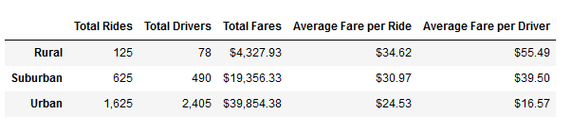

**Figure 2 Total Fare by City Type**

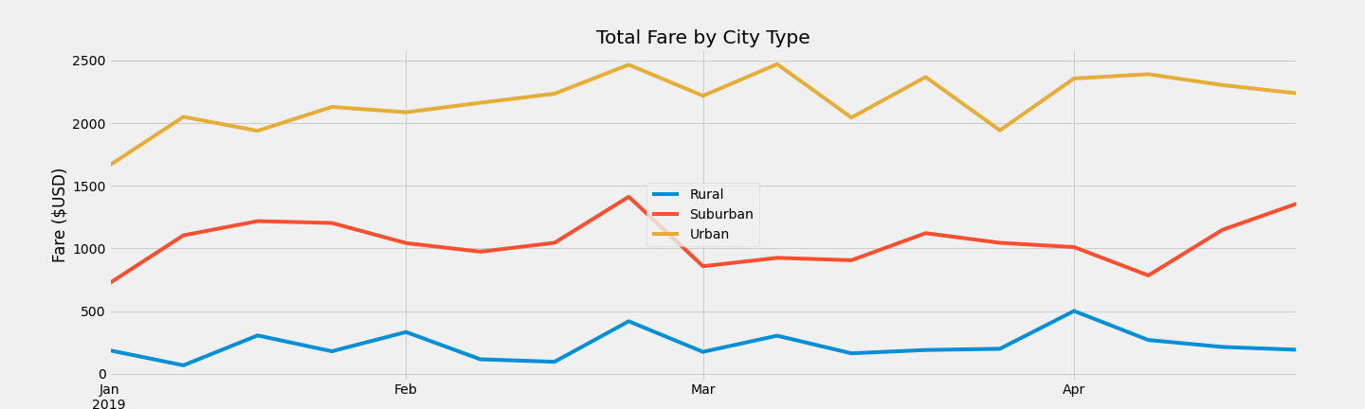

**Rural cities**

From figure 2 we can conclude revenue generated from Rural cities are low compare to Suburban and Urban cities.

**Suburban cities**

Suburban cities are in the middle when it comes to revenue generation.

**Urban cities**

Revenue generation in Urban cities are highest compare to other cities.

**Summary**

Based on the analysis we have several business recommendations

* To improve services in rural area fare must be lowered. By lowering the fares more people will likely to use the service for transportation. Rural cities tend to have less traffic compare to Urban and Suburban cities so its leads to less consumption of fuel and less time to complete a trip. If more people start to use the service in rural cities more driver will start to do ride sharing.
* We can introduce some offers for Suburban cities based on holidays to improve number of rides which eventually will increase total revenue.
* We can compensate lower fare in rural cities by increasing a small percentage of fare in Urban cities. The amount of increase in fare should be very small so that competitor will not have any advantage. By doing this we can ensure to increase affordability for underserved neighborhoods.